Specification and automatic generation of Interconnect, test bench, reference model and their interfaces for chip design and system-level design

The RTL coding tasks falls into two categories:
- Algorithmic: the core data-paths and control logic that differentiates your implementation from the competition: For example: your MPEG implementation, your traffic manager, your cache.
- Chip design and verification infrastructure: all the additional code, constants, and connectivity required to turn your algorithm implementation into a functional chip. For example: block inter-connect, programmable register access, instruction set mapping, block test-benches, state elements, ...

The algorithm implementations change dramatically from project to project. Chip and verification infrastructure creation is repetitive by nature and does not change much from project to project. Design and verification infrastructure needs to be consistent and common across the domains in which it is used such as RTL design, reference modeling, verification, and software tool development. Infrastructure is used for seamless communication between the different domains.

The FPL solution automates the chip design and verification infrastructure generation tasks. The key characteristics of the solution are as follows:
- Single source input to describe all of the design and verification infrastructure on a given chip design project.
- Integrated software tool to automatically generate the necessary infrastructure.
- Integrated software tool to check the consistency of the single source input
- Consistent set of interfaces across RTL design, verification, reference modeling, and software tool development domains.
- Significant reduction in setup and maintenance time for infrastructure specification and generation.

Definitions-please see figure 1 for references to each definition (e.g. RTL1, TB1, RM1, etc.). The line from the compiler to the generated component is labeled. The labels are described below.
- RTL Design
- Design under test (DUT) (RTL1):
The RTL design is instantiated in the test bench. The instantiated design is defined as the “design under test”.
- Interconnect and Design Hierarchy(RTL2)
A design hierarchy is a hierarchy of functional blocks to manage the complexity of the underlying design.
- Module interfaces: Input and output interfaces for a design
- RTL instantiations: The set of actual connections from one module to another.
- Interconnect - functional blocks connected to one another to facilitate the transfer of information which is processed by an algorithmic implementation contained in the functional blocks.
- State: Units contain memories, registers, register files the contents of which are updated on a clock edge and optional enables. The collection of one or more state elements in a unit can be captured known as the current state.
- Generated constants, generated containers and generated logic inside of DUT (RTL3).
Bit ranges are used for signals, registers, memories, register files, and FIFO’s.
- User logic (RTL).
  - The algorithmic logic instantiated inside of the functional blocks.
- Verification components
- Used in the reference model and the test bench.
- Vectors: Set of input or output ports associated with a unit whose values are captured on a certain event (e.g. valid bit is asserted or every clock cycle). The vector capture mechanism for the entire simulation is turned on at a certain event or time (e.g. after reset). The vector capture for the entire simulation is shut off at another event (e.g. maximum number of events or clocks occurred or maximum number of errors).
- There are 2 types of vectors – stimulus and expected. Stimulus vectors drive the inputs of the DUT. Expected vectors are compared against the outputs of the DUT either at a clock edge (cycle accurate vector) or on an event (transaction accurate vector).
- State data: Is the state captured at the clock edge or on an event. A set of registers or a register file in a unit whose values are captured on a certain event. The state data capture mechanism for the entire simulation is turned on at a certain event or time (e.g. after reset). The state data capture for the entire simulation is shut off at another event (e.g. maximum number of events or clocks occurred or maximum number of errors).
- Test benches
- Top-level test bench: a container that holds the elements of the test bench. See the remaining elements in this section (TB1).
- DUT instantiation: A unit instance in the chip design hierarchy is instantiated in a test bench and connected to the other components in the test bench.
- Stimulus memory instantiation TB4: Stimulus vector memory contains the set of stimulus vectors generated by the reference model and the header which contains the vector id
- Expected memory instantiation TB6: Expected vector memory contains the set of expected vectors generated by the reference model and the header which contains the vector id
- Architectural state memory: contains the expected architectural state (TB5).
- Comparators
  - Expected Vector comparator TB2: Vector comparator which compares DUT output vector and expected vector memory on an event or clock and generates a set of match and mismatch signals
  - State data comparator TB3: State comparator which compares DUT state and state memory on an event or clock and generates a set of match and mismatch signals
- Test bench – RTL design interface: The stimulus vector memory is connected to the DUT inputs and the DUT outputs are connected to the expected vector comparator
- Reference Model
- Reference model simulator (RM1)
A simulator that models the functionality of the chip design being verified. The simulator can be either cycle or transaction accurate.
- Units: Functional
Units that are used to model the behavior of an equivalent hardware unit at the interfaces and optionally the internal state
- Interconnect and Design Hierarchy (RM5)
  - A design hierarchy is a hierarchy of functional blocks to manage the complexity of the underlying design.
    - Module interfaces: Input and output interfaces for a design
    - RTL instantiations: The set of actual connections from one module to another
  - Interconnect
  - Functional blocks connected to one another to facilitate the transfer of information which is processed by an algorithmic implementation contained in the functional blocks.
- Generated constants, generated components, and generated logic inside of the units (RM6).
- User logic (RM7).
The algorithmic logic instantiated inside of the functional blocks.
- State (e.g. memories, register files) – see definition 2c above
- Vector writers
  - Stimulus RM2: Stimulus vector writer writes out stimulus vectors based on an event or clock to a file or socket
  - Expected RM4: Expected vector writer writes out expected vectors based on an event or clock to a file or socket
  - Expected state dataRM3: Arch state writer writes out arch state based on an event or clock to a file or socket
- Communication Mechanism Between the Reference model and Test bench (transport)
- Vectors and sockets or files: see definition 3b above.
  - A unit’s input vector (C1-the inputs to a unit) in the reference model are captured every cycle and are written to a file or socket which is then read by the test bench and then are applied to the inputs of the DUT.
  - A unit’s output vector (C2-the outputs of a unit) of the reference model are captured either every cycle or on an event and are written to a file or socket which is then compared to the outputs of the DUT in the test bench.
  - State data (C3).A state data element in a unit in the reference model is captured every cycle or on an event and is written to a file or socket which is then compared in the test bench to the corresponding state in the DUT.
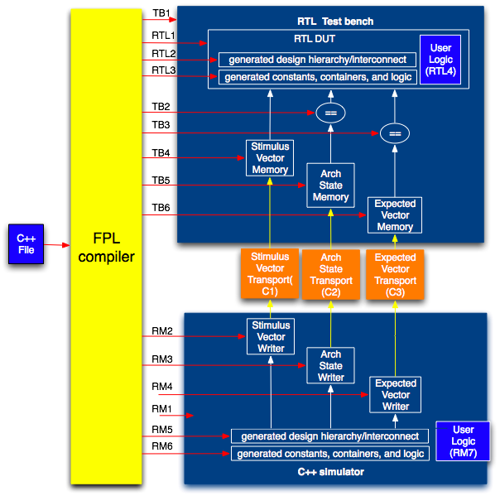
Figure 1. Overview of infrastructure for RTL design, test benches, reference modeling

Current method and issues
A fragmented design flow exists in RTL design teams as shown in figure 2.
- Currently the design, test bench and reference model implementations are built by separate teams using separate tools
- Inter-domain interfaces, constants, vector events, etc. are maintained manually
- Significant duplication of effort
- Lack of consistency

Maintenance is also a big issue, particularly for chip and verification infrastructure. Design changes must be reflected in C++ models, verification suites, software memory maps, and chip documentation etc. Figure 2 shows an example set of separate specifications that must be maintained in parallel.Changing the same information in multiple places is tedious and error-prone. Changing the information in one place saves time in many ways.
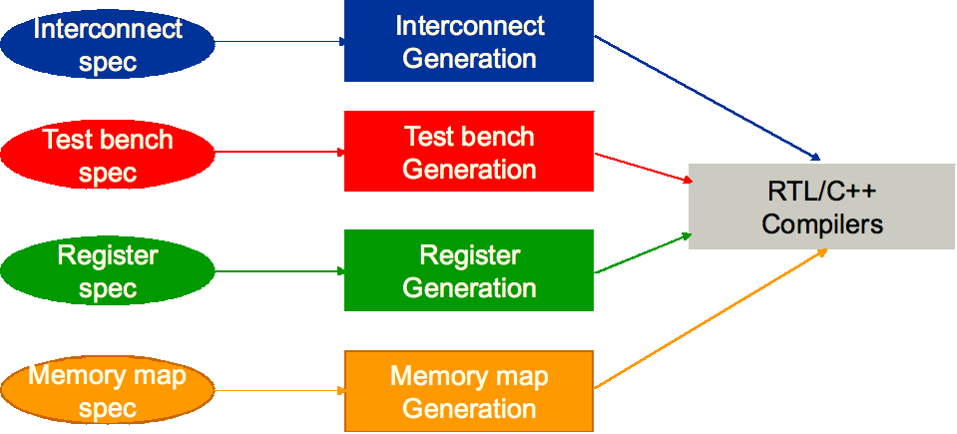
Figure 2. Fragmented design flow

Figure 3 shows the issues related to the exchange of information between C++ ref model team, verification team and design team. They all must create interfaces between the 3 different domains manually, make changes manually and debug the interface mismatches between the 3 different domains manually which results in significant productivity loss).

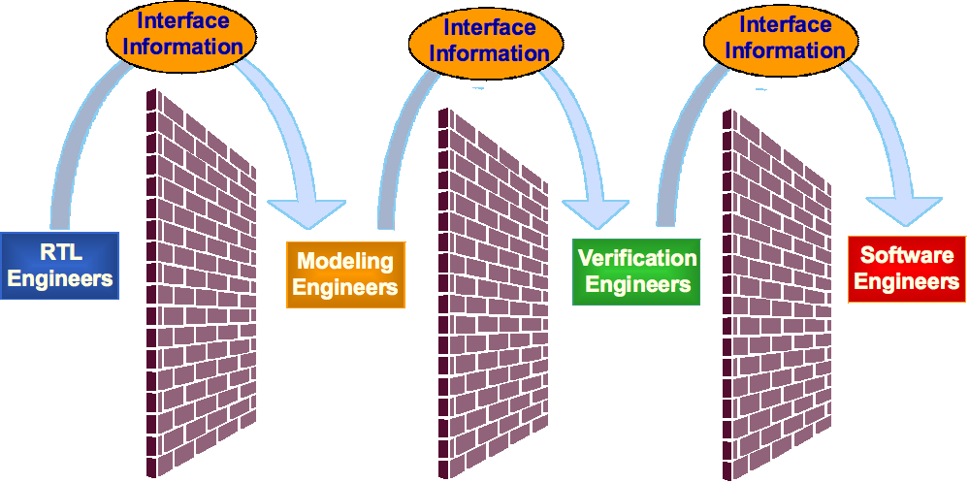
Figure 3. Information exchange between different teams on a project

New method
The FPL design platform enables the automatic generation of the design and verification infrastructure components for a given design (C to infrastructure solution which is highly complementary to a C to gates or C to RTL solution). It includes a super compact input description based on C++, a retargetable compiler, a comprehensive set of hardware building blocks and a complete methodology. The solution completely automates the generation of key building blocks such as design hierarchy, interconnect, test benches, memory maps, register files, FIFOs, buses, etc. In addition, the infrastructure generated is in the form of synthesizable RTL and C++ which can be seamlessly integrated into existing design environments with minimal overhead. This high degree of automation will enable a very high level of design & verification productivity and frees up the designers to focus on the highest value-added activity of designing the actual design IP on a project (the algorithmic/control blocks on a chip).

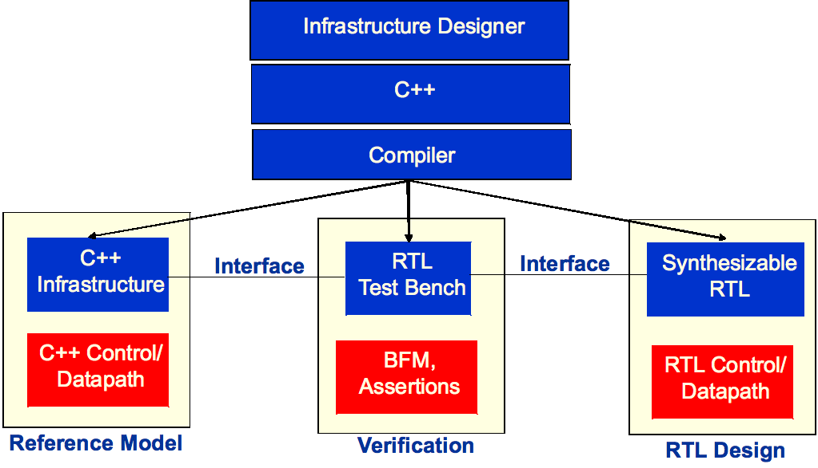Figure 4. FPL Flow diagram

FPL Flow diagram
The flow shown in figure 4 is described in the following section:
- Infrastructure designer
  - A graphical user interface (GUI) is used to draw the design hierarchy and create the following: connections between unit instances at the same or different hierarchy levels using end points, design blocks, components in functional units, registers/register files, test benches, and constants.
- C++ description
  - The GUI automatically generates highly compact C++ code that specifies the design and verification infrastructure for a given design. Alternatively, the C++ code can be written by hand. The C++ code has some very powerful built-in constructs to fully describe the infrastructure in the form of interconnect, design hierarchy, memory maps, registers, register files, test benches, etc.
- Compiler
  - The compiler compiles the generated or handwritten C++ description and generates the following set of components.
  - Reference model - see definition in section 5 above. The compiler automatically generates the hierarchy, interconnect, containers, and constants for the C++ reference model. In addition, the vector readers and writers, state data writers are automatically generated. The generated readers and writers are equivalent to the corresponding elements in the test bench. The user then writes a C++ description representing the algorithms and connects it to the infrastructure code in order to complete the reference model.
  - Verification components - see definition in section 3 and 4 above. The compiler automatically generates test benches at each level of the design hierarchy where specified. The compiler automatically generates the components in the test bench to connect the test bench to the reference model and instantiates the design under test. The user can optionally add components such as bus functional models and assertions to the automatically generated test bench.
  - Synthesizable RTL - see definition in section 2 above The compiler automatically generates the hierarchy, interconnect, containers, and constants for the RTL design. The user then writes the RTL code representing the algorithms and connects it to the infrastructure code in order to complete the reference model.

Infrastructure Components
The first infrastructure component that is developed is the design hierarchy and interconnect because it serves as the foundation for most infrastructure components.
  - Units are containers and have interfaces.
  - Interconnect connects the units.
  - The units in the design hierarchy are the containers for the other chip design elements, including other infrastructure elements such as memory map elements (e.g. address decoders, register files, registers).
  - The unit interfaces are used to instantiate the RTL DUT in the RTL test benches.
  - The design hierarchy is used to construct the reference model

The design hierarchy for an example chip is shown in figure 5. The example hierarchy contains 3 units (a, b, c) that are connected.

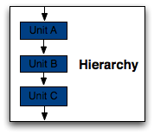
Figure 5. Example design hierarchy

The rest of the design infrastructure consists of the following components.
- Registers/register file: added to design hierarchy in RTL and optionally in C++ ref model
  - Can be created using the same bit range and field objects to create signals and ports
- Memory map
  - Addressable objects (e.g. registers/register file) in units can be added to the memory map automatically
  - Unit IDs can be manually or automatically assigned to units
  - Generates equivalent constants and functions in C++ and RTL

The verification infrastructure consists of the following components:
- Verification components (vectors and state data) which are associated with units in the design hierarchy.
- Test benches
  - No need to specify vector names or state data names: inferred from DUT
  - Automatically connected to C++ reference model vectors/state data and DUT
  - Parameterizable (e.g. set # of errors/simulation cycles)

The process for developing and compiling the design and verification infrastructure components are as follows:
- Compile the specification(s) and generate the following –
  - C++ reference model, test benches, RTL interconnect, and the rest of the design infrastructure components.
- Usage model
  - Compile the C++ reference model.
  - Compile the RTL.
  - Simulate the C++ reference model, generate the vector and state data files.
  - Simulate the RTL test bench using the vector and state data files.
  - View the results and then fix any problems.

Co-simulation using a reference model and an RTL DUT
Our example will show how a reference model unit b can be replaced by an RTL unit. Example communication mechanisms between the reference model and the RTL DUT include a shared memory or a socket. In figure 5 there are three units in a design hierarchy (a,b,c). The design hierarchy is part of the infrastructure in the reference model and an equivalent RTL model. In each model, unit A is connected to unit B and unit B is connected to unit C.
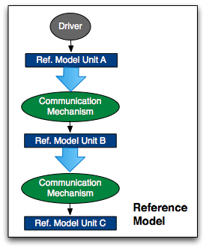
Figure 6. Co-simulation model: using a reference model to drive the inputs of an RTL DUT directly.

A simulation with the reference model is run and the output transactions of the chip or a particular unit are saved.

In figure 6 unit B in the reference model is replaced by an equivalent RTL unit B.
  - The outputs of unit A in the reference model are connected through a communication mechanism (a socket or shared memory) to the inputs of unit B in the RTL model
  - The outputs of RTL unit B are connected through a communication mechanism (a socket or shared memory) to the inputs of the unit C in the reference model.
  - The reference model simulator and the RTL simulator are then executed.
  - The output transactions of the co-simulation are compared to the saved reference model transactions and mismatches are reported.
  - The user then debugs the mismatches and makes changes to the reference model and/or the RTL DUT.

Reference model, vector/state data, and RTL test bench methodology
The verification methodology flow shown in Figure 7 uses a reference model to verify an RTL DUT in a test bench. The reference model generates stimulus expected results and state data. The reference model simulator and the RTL simulator are then executed in either the same process if a shared memory communication mechanism is used or in different processes if a socket is used. A controller reads the stimulus memory which drives the DUT inputs. The DUT processes the input(s) and produces transaction(s).
The figure shows the connections between the verification component writers in the reference model and the corresponding readers in the RTL test bench.
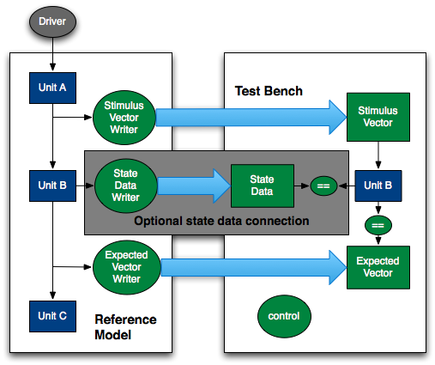
Figure 7. Verification methodology flow using separate reference models and test benches.

The simulation steps are as follows:
- The driver, reference model and driver and RTL test bench are reset by a master controller.
- The driver creates stimulus which drives the inputs of the reference model. The inputs of the reference model are connected to the inputs of unit A.
- The automatically generated stimulus vector writer is driven by the outputs of unit A (stimulus vectors). The stimulus vectors are captured on each transaction by the stimulus vector writer which sends the vectors to the stimulus memory (buffer) in the test bench.
- Unit B processes the transactions from unit A and generates transactions on its outputs.
- As shown in figure 7, the expected vectors are the outputs of unit B in the reference model. The expected vectors are captured on each transaction (i.e. on a clock or boolean event) by the expected vector writer. The writer then sends the vectors to the expected vector memory (buffer) in the test bench.
- For each output vector from the RTL DUT (e.g. unit B)
    - If the transaction is valid (e.g. based on the same event used to capture the expected vector from reference model), the output vector is compared to the expected vector by the test bench comparator.
    - The vector matches and mismatches are captured by the match and mismatch reporter in the test bench.
- Optionally the internal state of the reference model can be compared to the corresponding state of the RTL model. As shown in figure 7 the internal state of unit B is captured by the automatically generated expected state data writer on valid transactions. The expected state data transactions are sent to the test bench. The test bench compares the expected state in the RTL DUT to the expected state from the reference model. The state data matches and mismatches are captured by the match and mismatch reporter in the test bench.
- The user then debugs the mismatches and makes changes to the reference model and/or the RTL DUT.

Summary
This methodology requires that a reference model be developed at the same time that the RTL model is developed. This methodology facilitates the rapid generation of test benches at all levels in the design hierarchy. The single specification, which is compiled, helps keep the reference and RTL models consistent with one another throughout the design cycle. Any differences between the reference and the RTL models are due to differences in the datapath, control, and algorithmic implementations which are flagged by the comparisons between the two models using the co-simulation or model to model comparison via test benches. The reference model is treated as the “golden model” in this methodology.

The method described above facilitates an incremental bottom up verification methodology. The reference model and RTL model leaf level units are developed and compared to one another using the test bench method described above. The upper level connections and instantiations are made in the reference model and the RTL model and different combinations of reference models and RTL DUT’s/hierarchies are compared to one another. This methodology facilitates the creation of test benches at all levels of the hierarchy. The benefits of the bottom up methodology are as follows:
- Mismatches between lower levels can be debugged (fine grained) before testing upper level hierarchies (coarse grained) in contrast to hand generated test benches which tend to be coarse grained only.
- Ability to drill down into the lowest level of the design and compare the reference and RTL models when there are mismatches at an upper level.

Invention Concepts
- A single source input based on C++ fully describes all the design and verification infrastructure (interconnect, test benches, memory maps, reference models). This input description is highly compact and enables a 10x-30x reduction in the lines of input code. The use of a single source guarantees consistent information in the generated verification and RTL components. Consistent information in different models eliminates parallel book keeping errors. Typical industry methods use different input languages to describe different parts of the infrastructure. Furthermore, infrastructure information is copied from one model to another model, resulting in simulation mismatch errors.
- The FPL GUI has been specifically designed to capture the various infrastructure components and the automatically generates the single source input.
- The FPL compiler automatically generates of equivalent infrastructure components (e.g. RTL interconnect, C++ interconnect, RTL test benches) from a single source. This significantly reduces the amount of time required to setup a design projects verification and design infrastructure. This also significantly increase the productivity of the design and verification teams on the project.
- The FPL compiler automatically generates the vector and state data communication mechanism between the reference model, the test bench, and the RTL model. The automatic generation of the vector and state data communication mechanism significantly reduces the amount of time used to setup and maintain a design project
- The FPL compiler automatically generates the comprehensive list of infrastructure components (e.g. design hierarchy and interconnect, constants, registers, SOC addressing mechanisms, FIFO’s, etc.) in both the reference model and the RTL model. This results in equivalent information being created across both the reference model and RTL domains, enabling consistency and easy verification.
- The FPL compiler automatically generates the assembler, the mechanism which automatically loads the binary files into the reference model and RTL compiler.
- The generated code in the different RTL and modeling languages eliminates consistency errors which are present using standard industry practices.
- The FPL compiler automatically generates documentation for the generated RTL and reference model infrastructure components.
- The FPL compiler automatically generates a co-simulation communication mechanism between the RTL and reference model
- Single source input and/or the GUI can be used to fully describe an instruction set architecture (ISA) which is then compiled using the FPL compiler which in turn generates the RTL and C++ components needed to build custom processors.
- Standard industry tools and existing methods combine the interconnect and design hierarchy into a single input. The FPL solution separates the design hierarchy, connection, and interface information in order to describe and generate the interconnect (see other patent). The separation of the information results in a significant reduction in the size of the input compared to conventional input methods (30x-50x reduction). The separation of information facilitates rapid design hierarchy and interconnect changes compared to conventional methods.

Benefits
  - Powerful GUI which is used to capture design blocks, interfaces, connections, design hierarchy, memory maps, and includes a code generator for automatically generating the equivalent C++ description
  - Highly compact specification: 10-30X reduction in lines of code compared to RTL
  - Hierarchy, interfaces, and connections are separated which makes it easier to maintain and make changes
  - 20X-50X reduction in effort required to develop and maintain the code
  - The interconnect and design hierarchy specification are implemented once instead of implementing the infrastructure in each domain – test benches, reference models, etc.
    - Capture once, Reuse everywhere
    - Make changes in a single place and propagate everywhere
    - Consistent set of interfaces across several domains
    - No parallel book keeping
  - Test benches are automatically connected to the generated C++ Reference Model and RTL design with a highly compact specification (very few lines of code)
  - A consistent set of interfaces are generated automatically (RTL, C++, test bench)
  - The generated design, test bench and reference model code is consistent by construction and no additional work is required to integrate the components
  - Single tool to generate all of the infrastructure automatically.
  - Applicable to all design environments (FPGA, ASIC, SoC, Microprocessor, etc.)
  - Generates industry standard RTL (Verilog, VHDL, SystemC, System Verilog) which can be easily integrated into existing design flows.

